Problem 1: Does overtime affect attrition of employees in the company

Descriptive Analytics
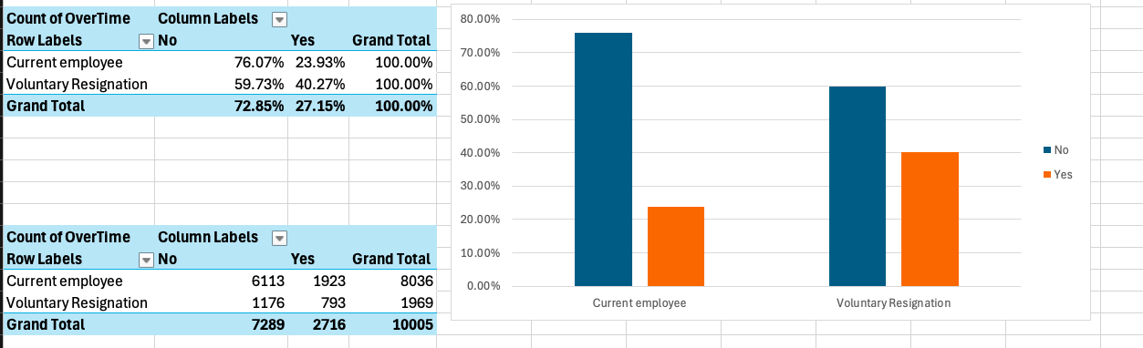
In the graph of comparing employees who resigned vs current employees, the proportion of employees who do overtime is greater than employees who do not do overtime for the group of employees who resigned.

Diagnostic Analytics
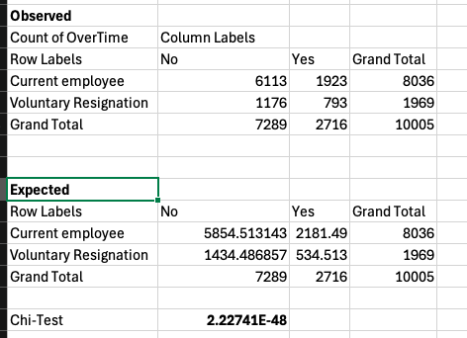
Using Chi-square test because both are categorical data, there is significance because p-value is less than 0.05.

Predictive Analytics
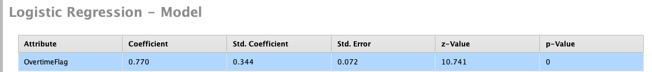
Class of High Interest: Range2(Resigned employees)
Since P-value is less than 0.05, Overtime flag has significant effect in Attrition
And since Coefficient is greater than 0 (0.077), it has positive effect on attrition.

For the recommendation: Since we cannot prevent overtime especially during delivery/production, we can plan ahead to avoid overtime and we can hire more employees to mitigate it as well. Since the number of overtime hours is not provided, we can find the sweet spot where it does not affect the attrition rate.

2. Factors that affect worklife balance

3. Duration of stay of employees before they resign

4hourly rate negative correlation with job satisfaction
5. relationship satisfaction correlation with worklifebalance

